Custom ocx and dll tests
- SCAUtils test This tests the operation of SCA dll's
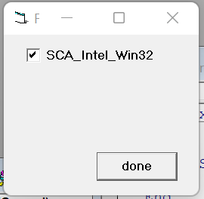
- SCA VB Utils test This tests the operation of SCA VB dll's
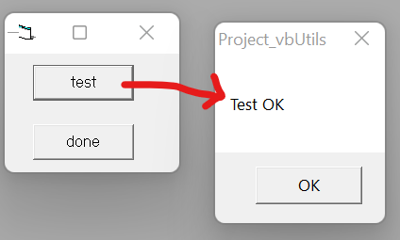
- SCAGraph test This tests the operation of SCAGraph32.ocx
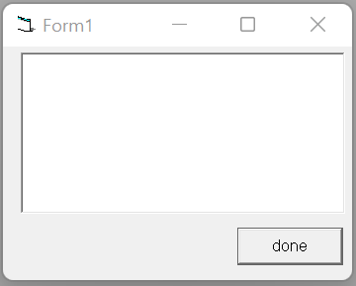
- SCAPointTransform test
This tests the operation of SCAPointTransform32.ocx
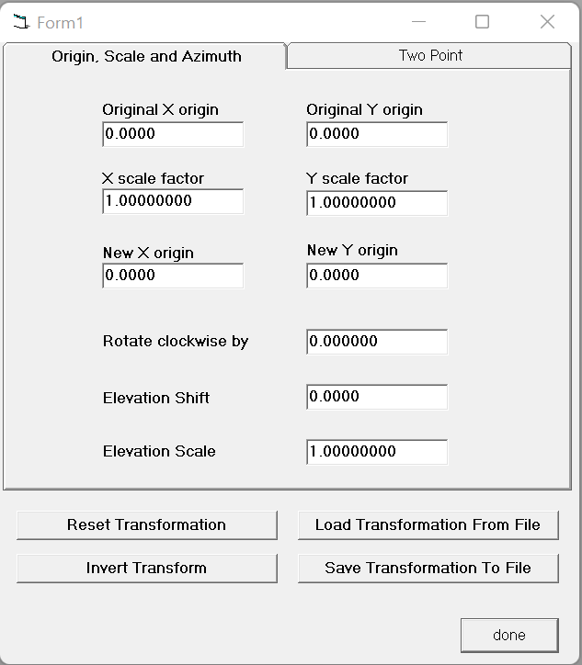

- SCAProjection test This tests the operation of SCAProjection32.ocx
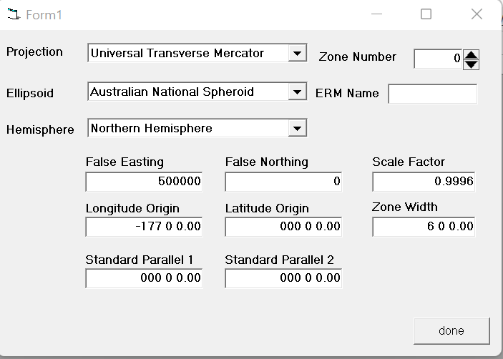
- SCARotation test This tests the operation of SCARotation32.ocx
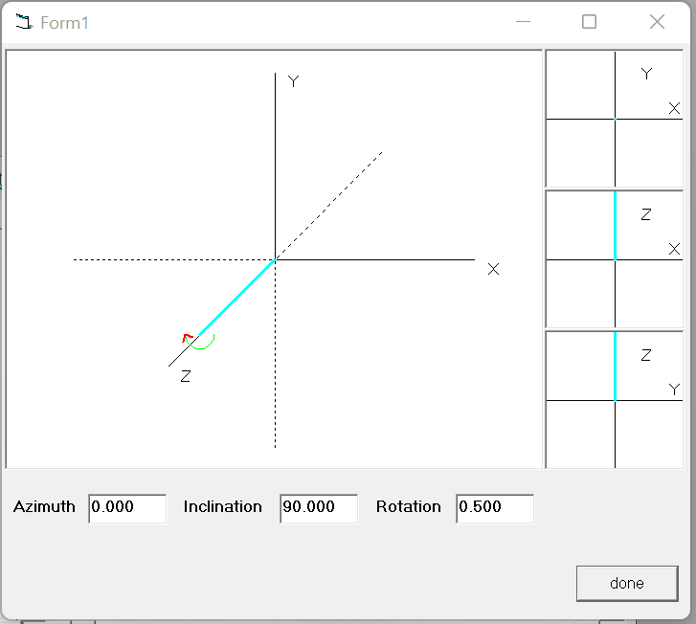

- SCASelectDir test This tests the operation of SCASelectDir32.ocx
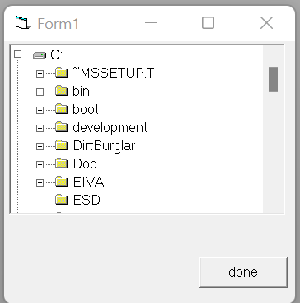
- SCAResizer test This tests the operation of SCAResizer32.ocx
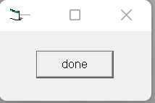
- SCAEditControl test This tests the operation of SCAEditControl.ocx
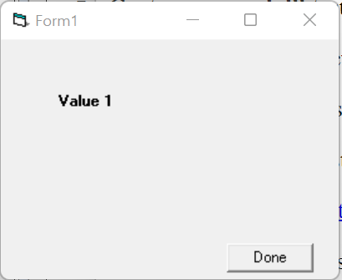
- SCAFileView test This tests the operation of SCAFileView.ocx
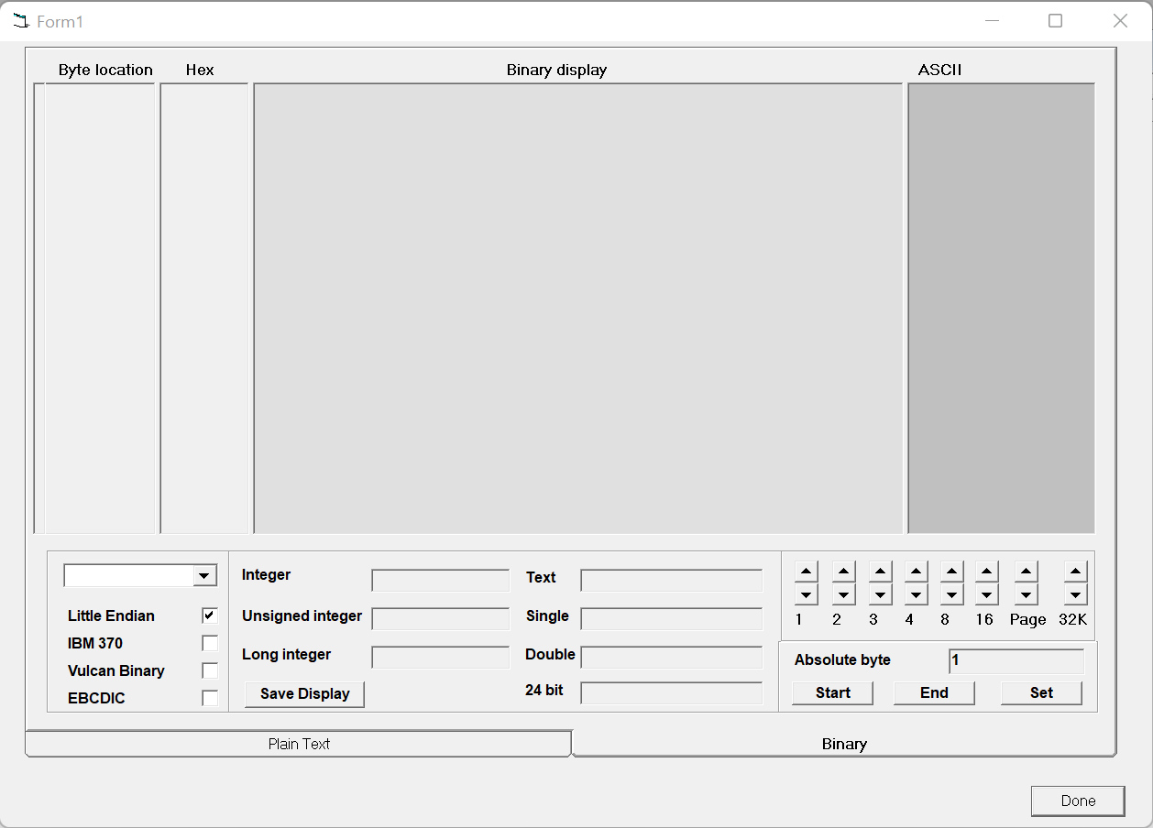
- SCAGridViewer test This tests the operation of SCAGridView32.ocx
- SCATreeView test This tests the operation of SCAVBTreeView.ocx

